Figure 1. Setting of the predefined chemical substance, where (s) means solid phase, (aq) means dissolved in water, and (g) means gas phase and (l) means liquid phase.

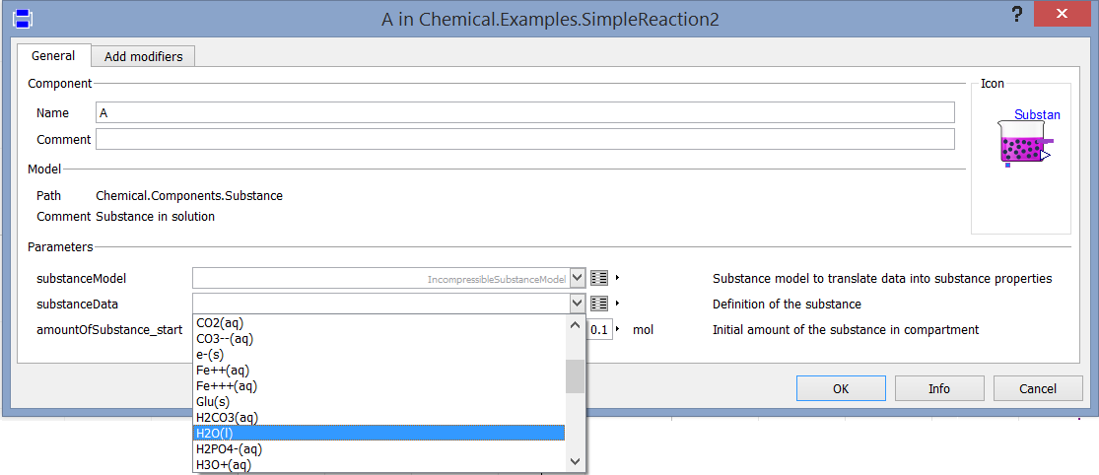

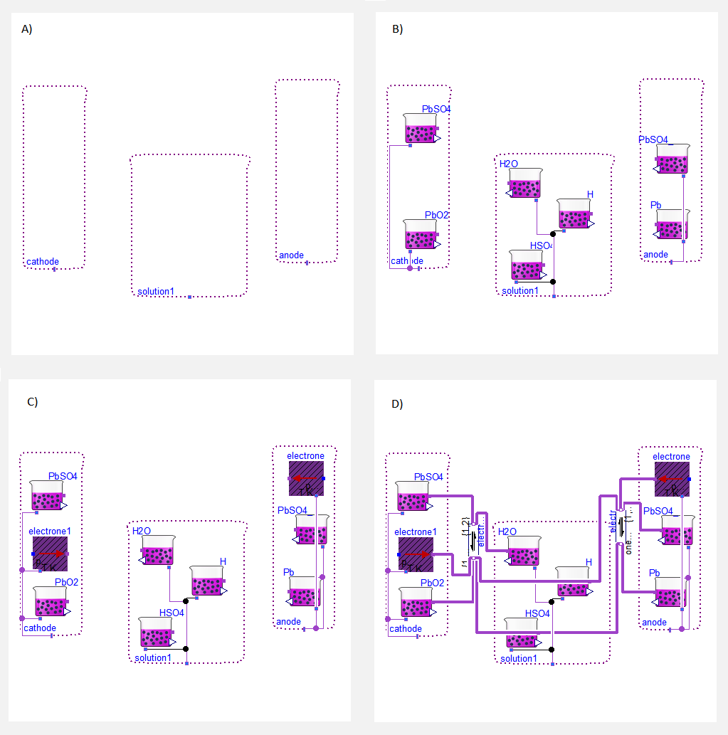

Figure 2. Building of one electro-chemical cell of lead-acid battery in four steps: A) adding chemical solutions, B) adding chemical substances, C) adding electrons, D) adding chemical reactions

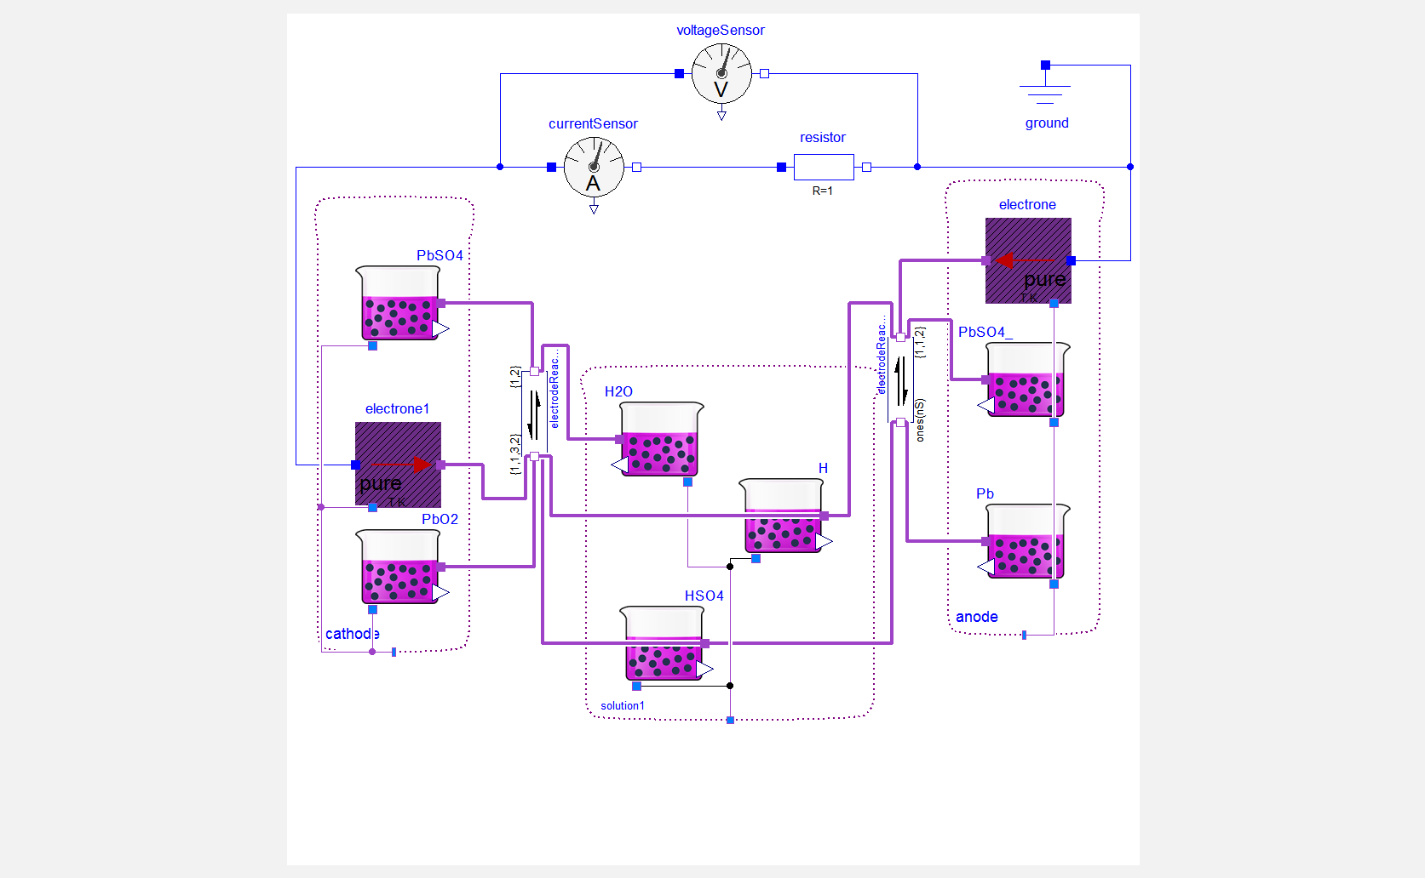

Figure 3. Discharging experiment of the lead-acid battery cell

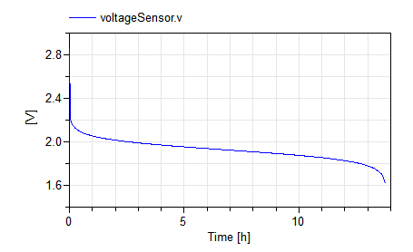

Figure 3. Discharging simulation of lead acid battery cell from of Figure 3 with the initial amount of substances as described in text.

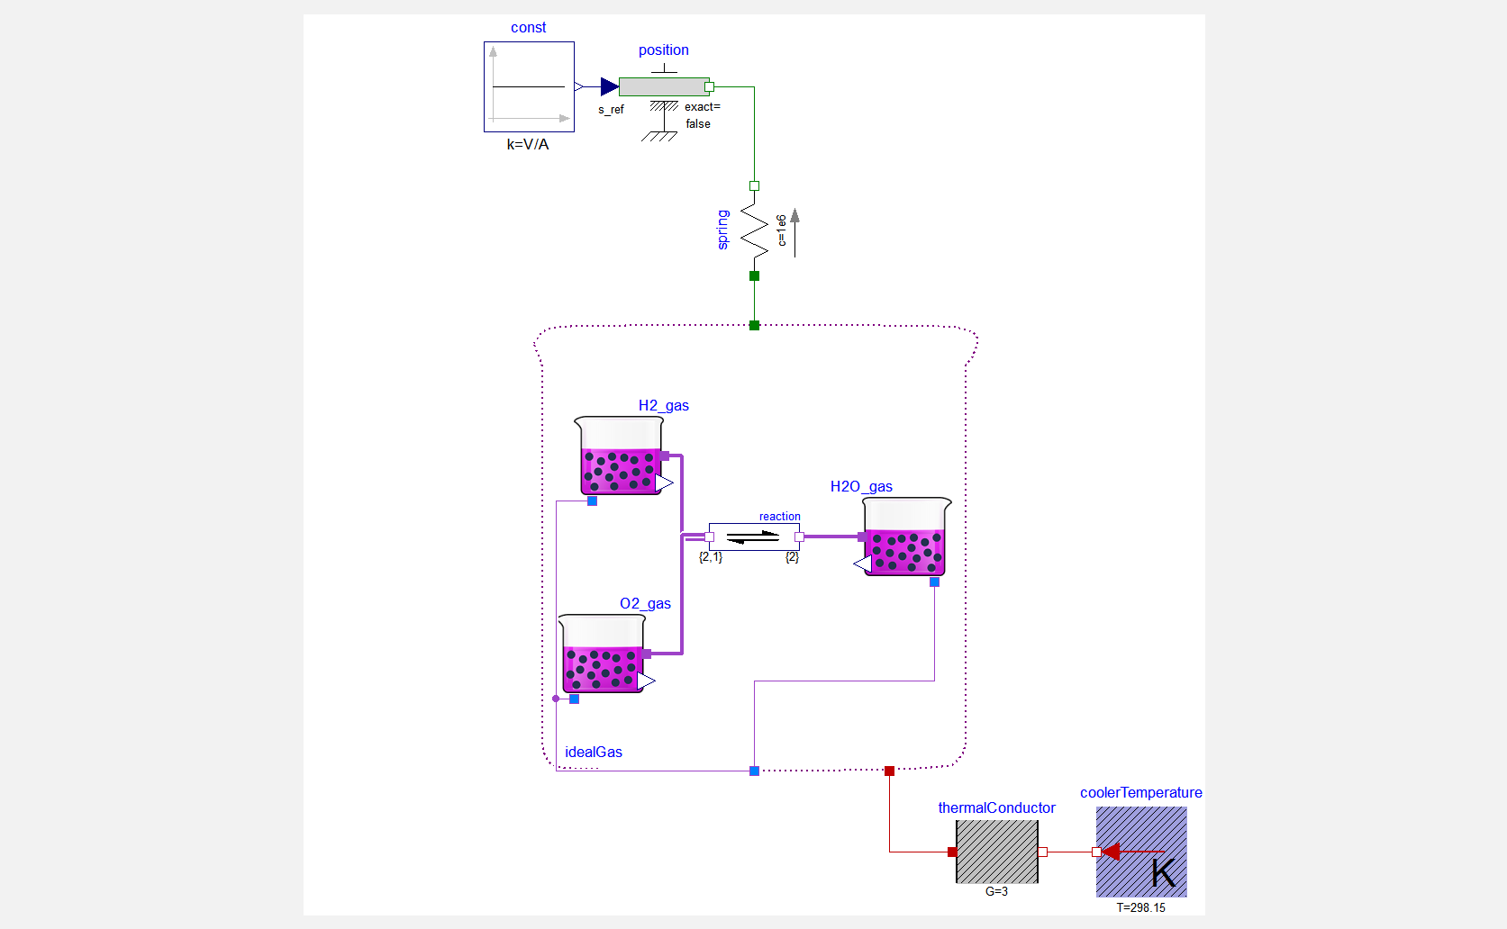

Figure 6. Hydrogen burning engine with the spring above the piston and the cooling to constant temperature environment.

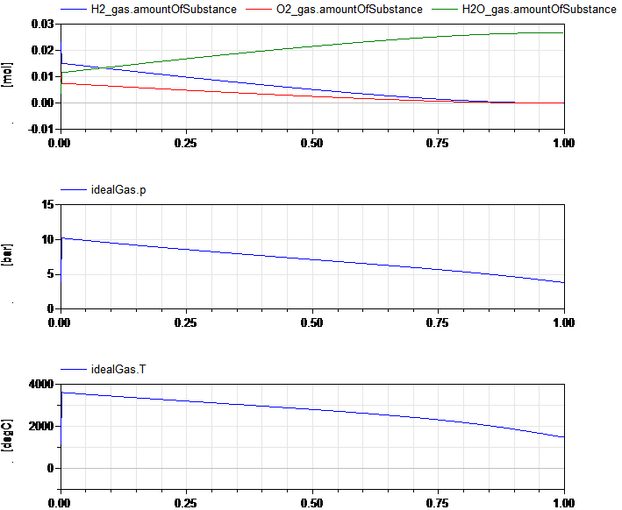

Figure 5. Simulation of hydrogen burning experiment of Figure 5. Initial phase of explosion is very fast - temperature reaches 3600°C from 25°C, the pressure reaches 10 bar from 1 bar. This pressure and temperature is generated because of very strong spring, which allows to change the volume only about 8% during the explosion.

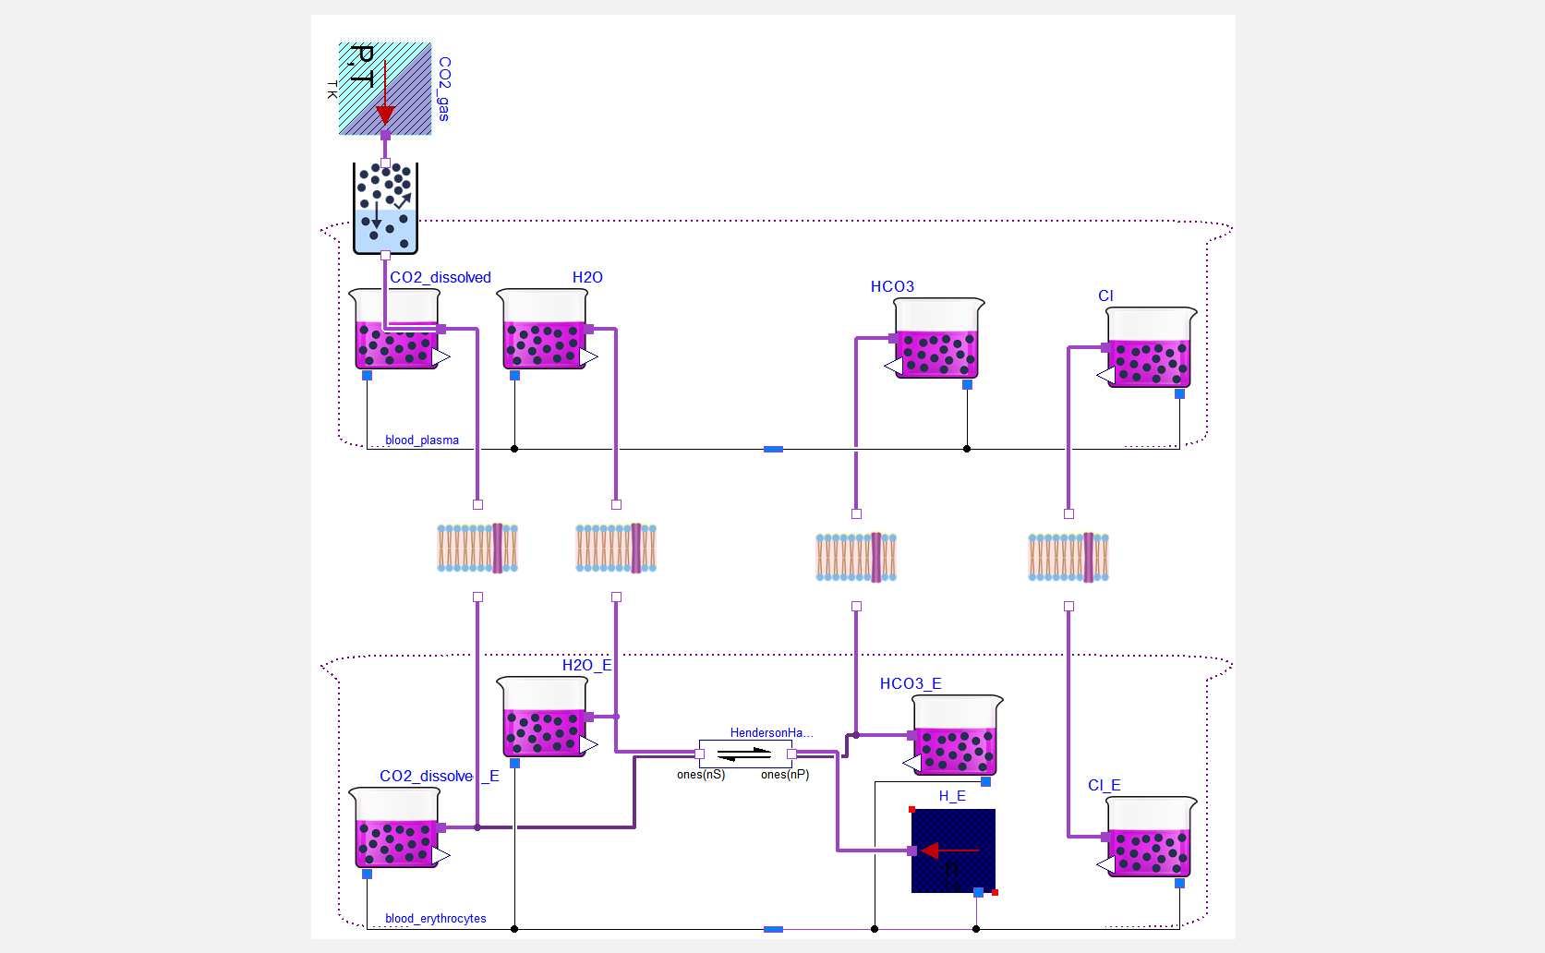

Figure 7. Hydrogen burning engine with the spring above the piston and the cooling to constant temperature environment.